# Input and Output Screens

index.html

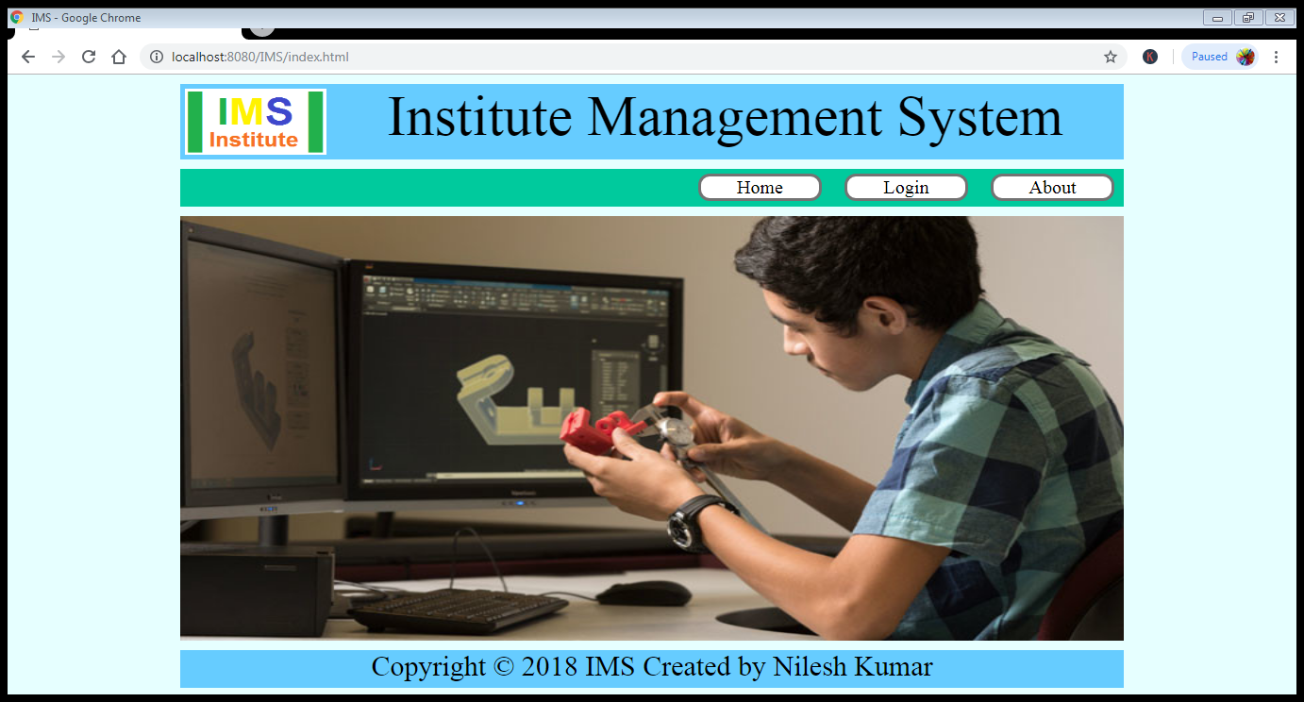

Admin_Login.jsp

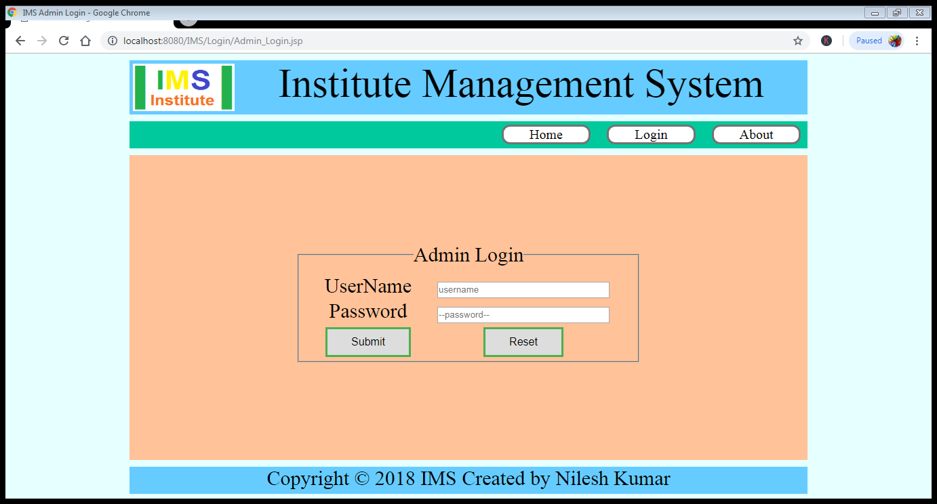

Teacher_Login.jsp

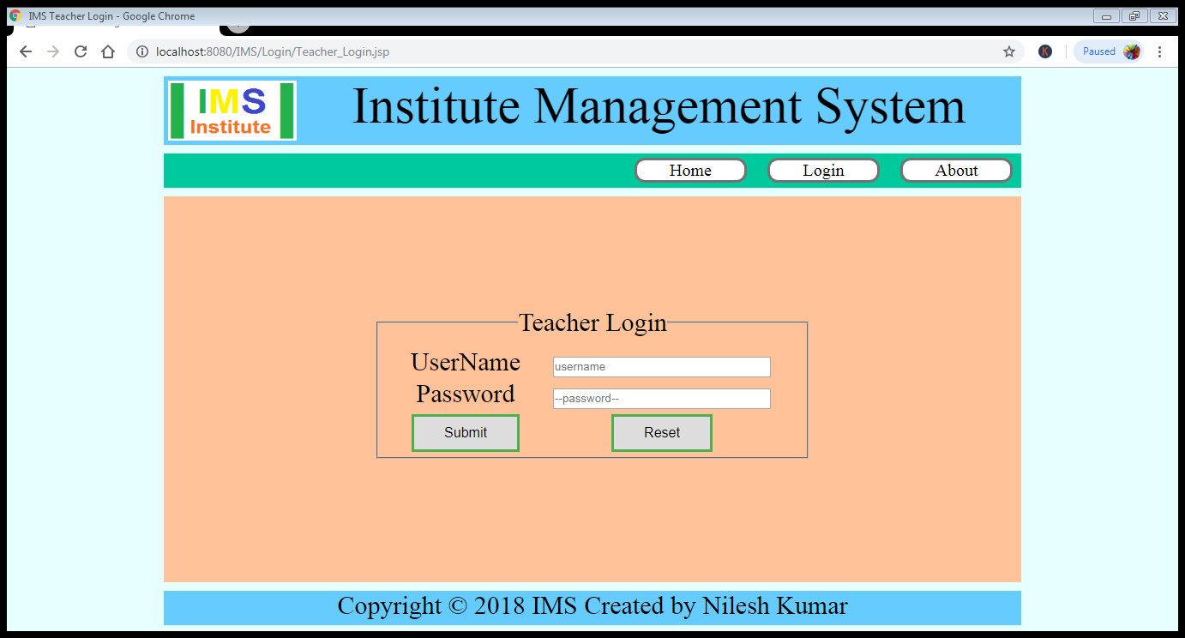

Student_Login.jsp

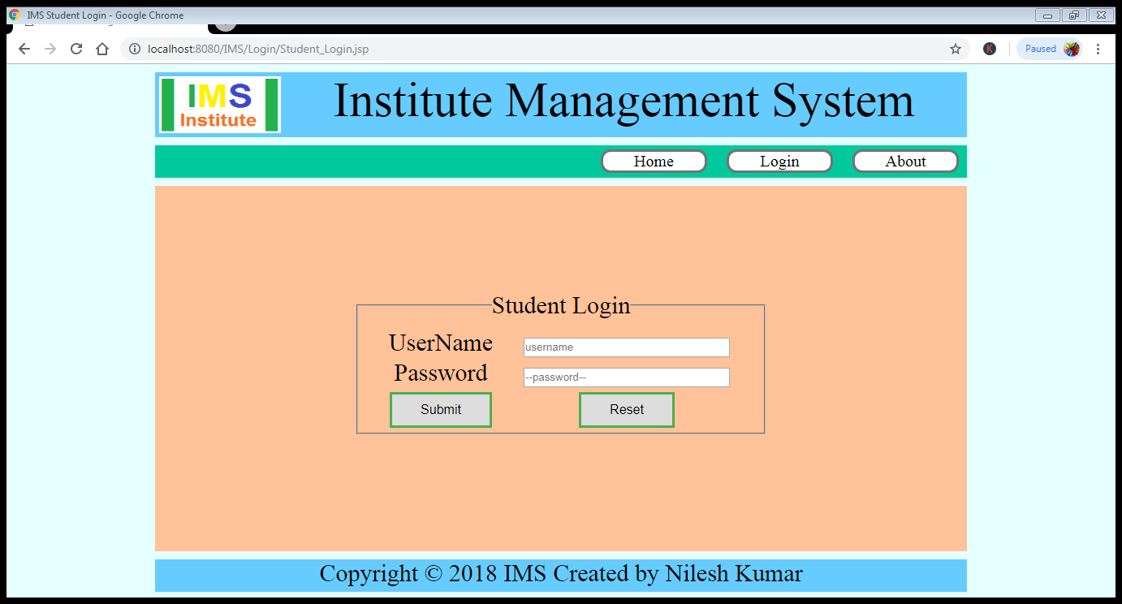

Admin Login

1. Username or Password is incorrect
2. Username or Password is Correct



(a) Output When Username or Password is **incorrect** through ConfirmUser.jsp to Admin_Login.jsp

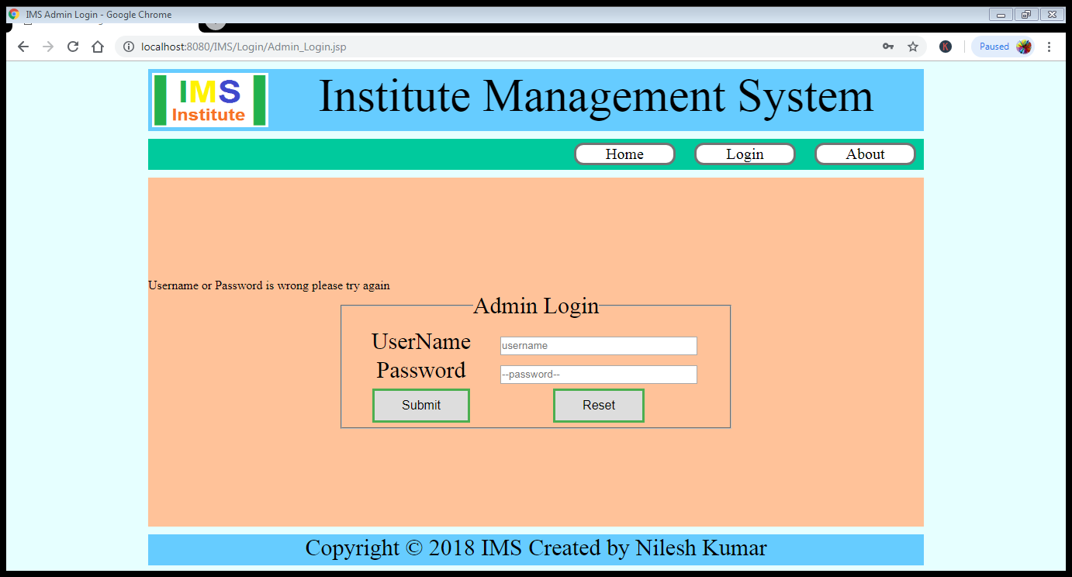

(b) Output When Username or Password is **Correct** through ConfirmUser.jsp to DashBoard.jsp

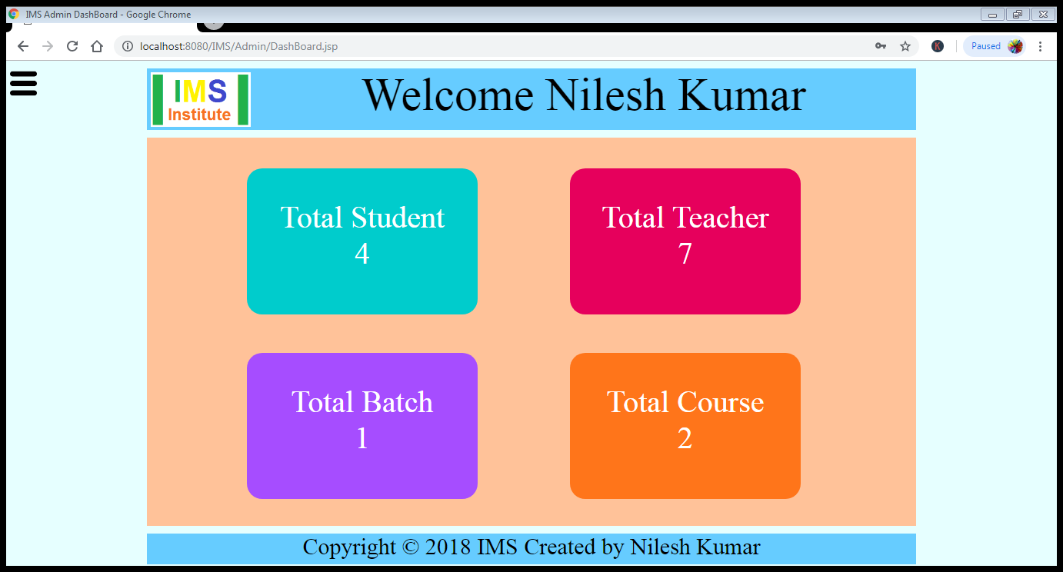

Clicking on Total Student, Student_List.jsp page will open.

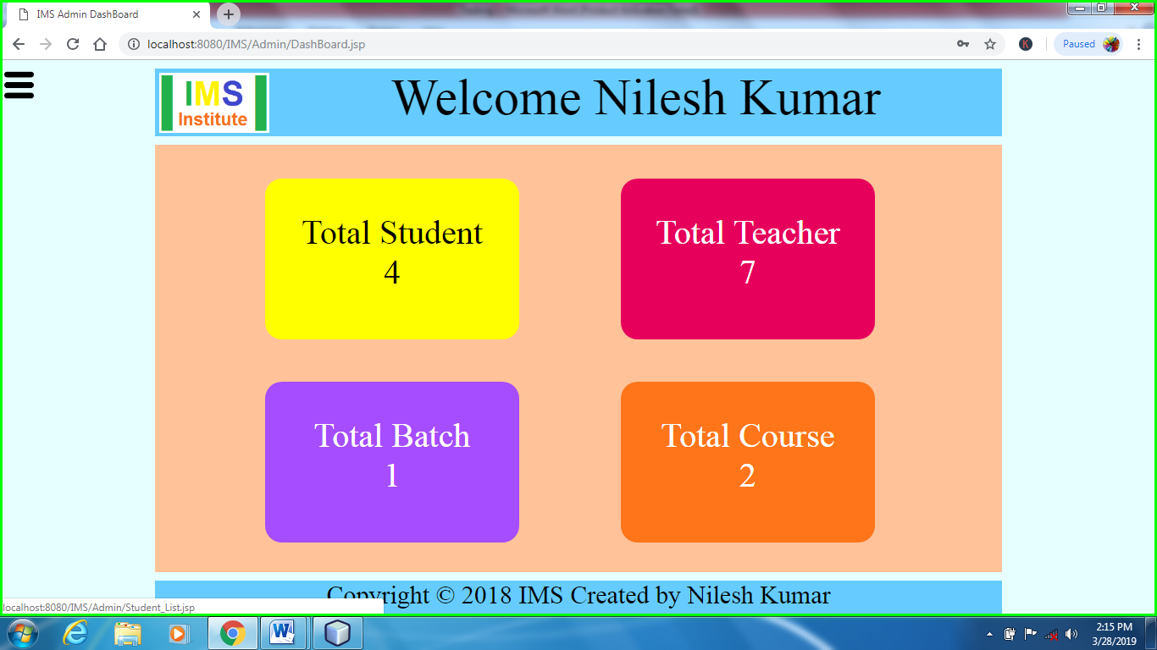

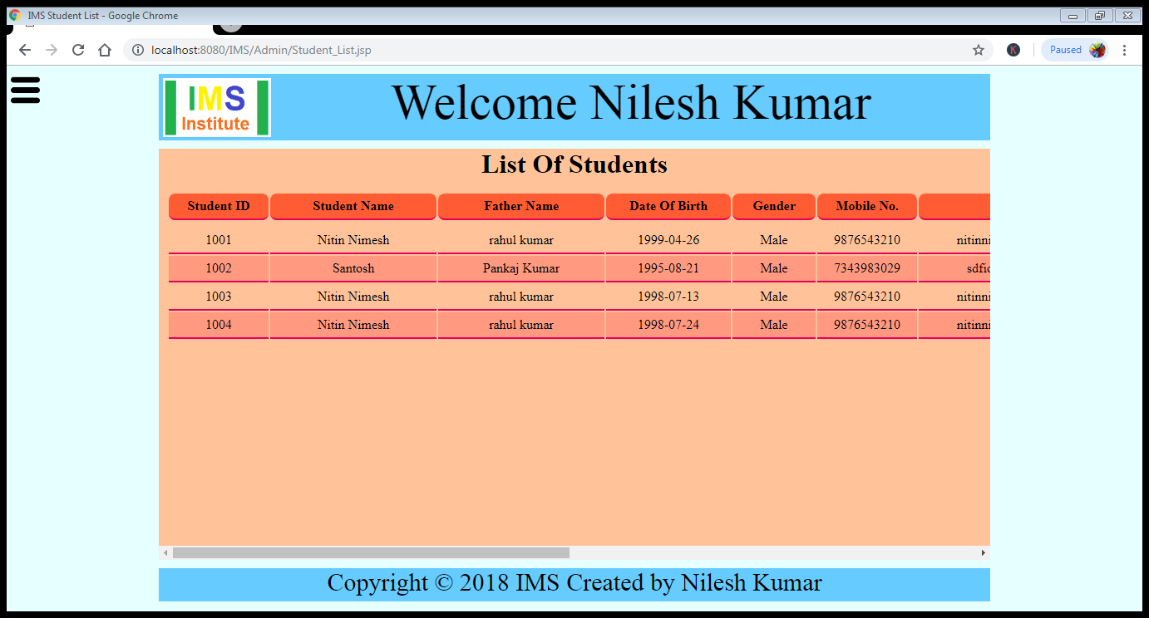

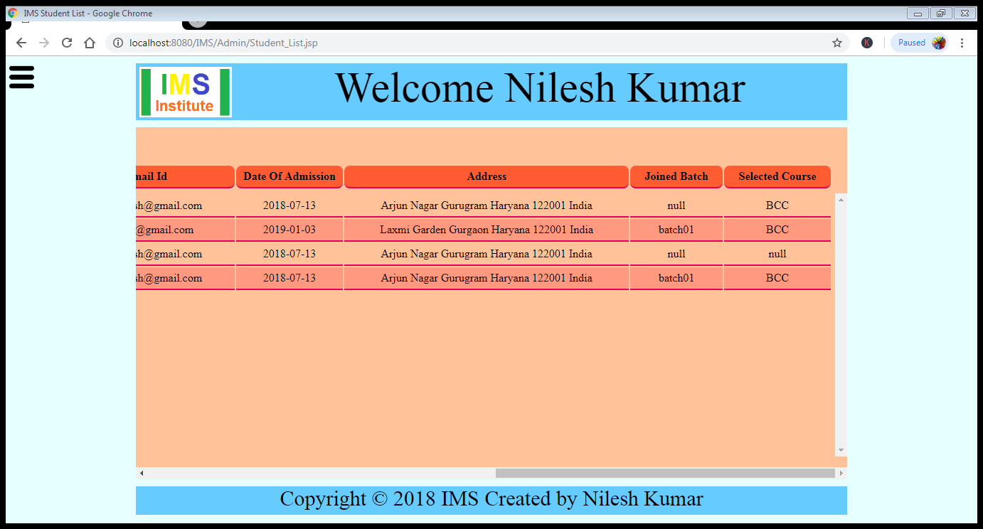

Clicking on Total Teacher, Teacher_List.jsp page will open.

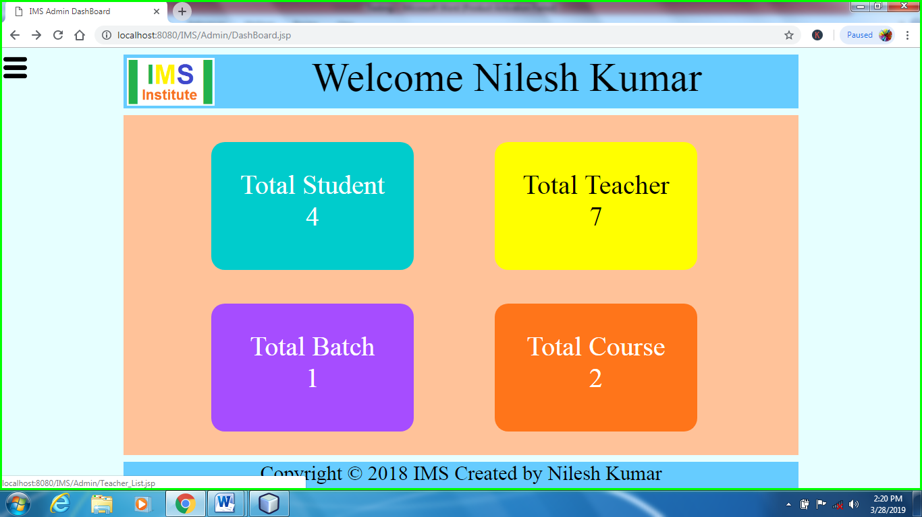

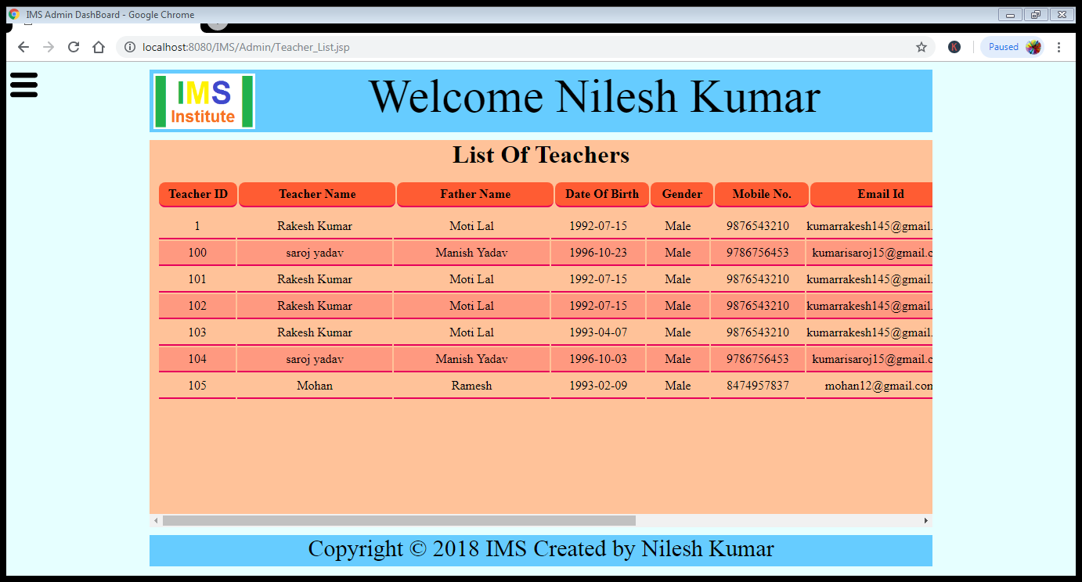

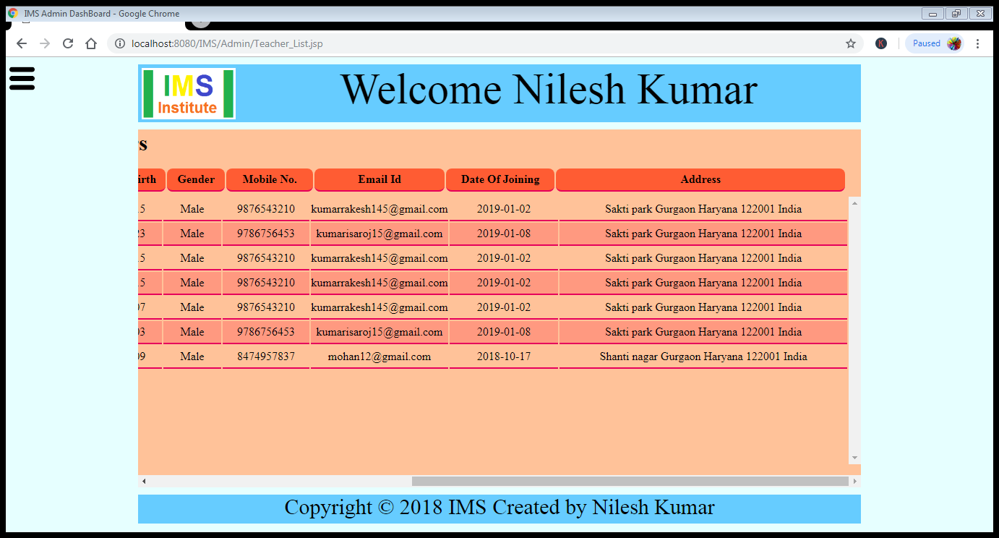

Clicking on Total Batch, Batch_List.jsp page will open.

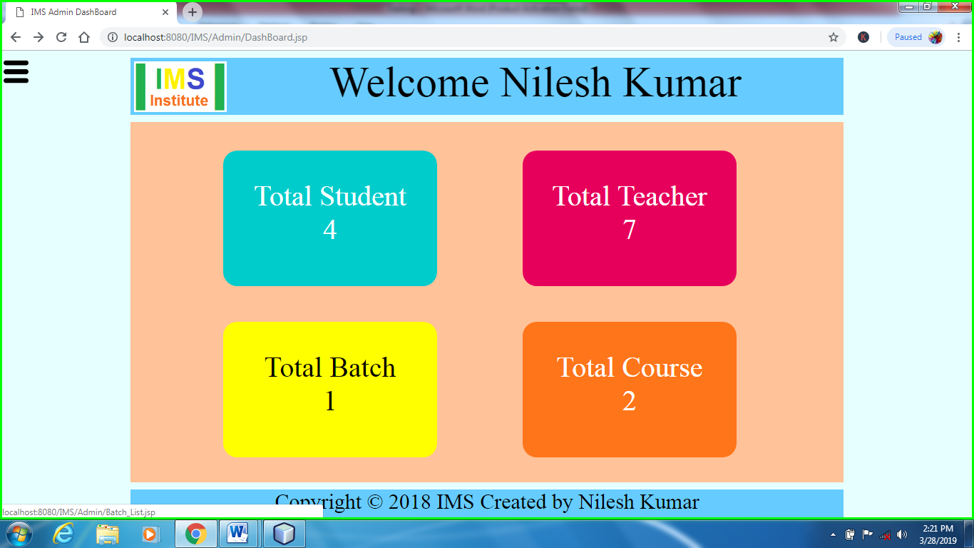

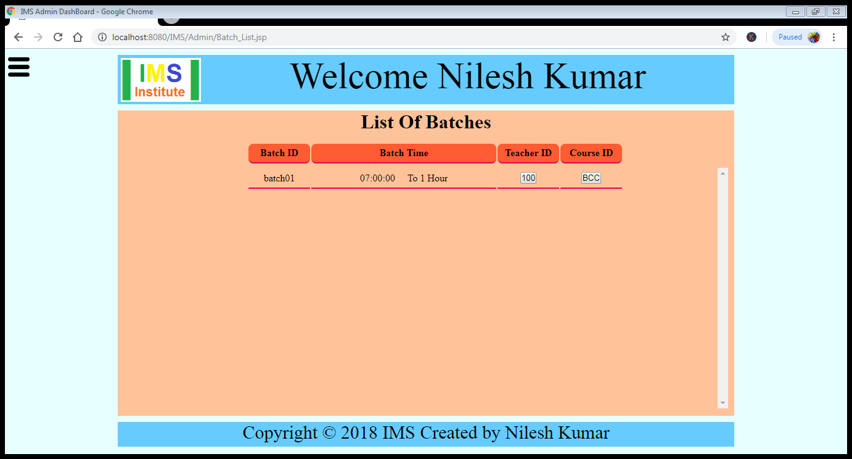

Clicking on Total Course, Course_List.jsp page will open.

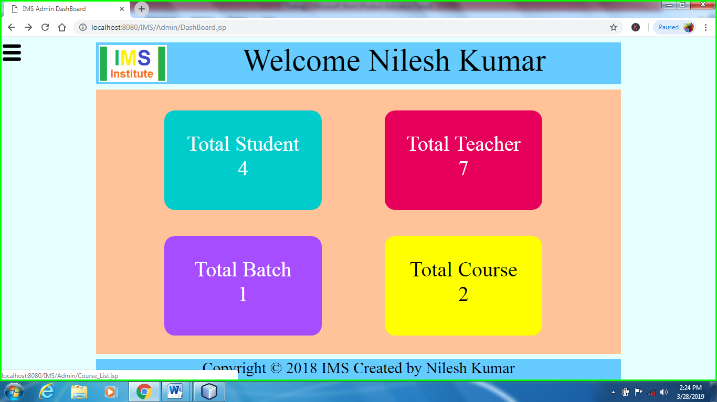

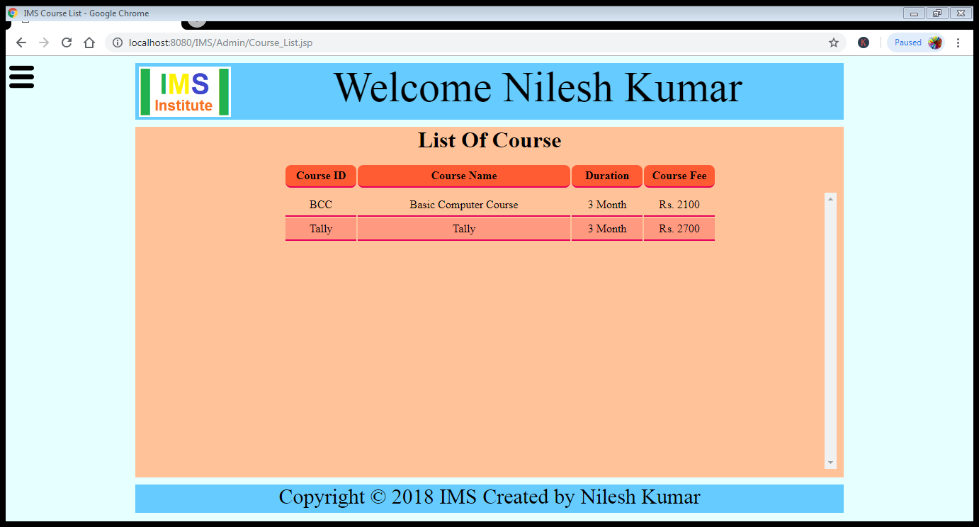

Staff Management on DashBoard of Admin

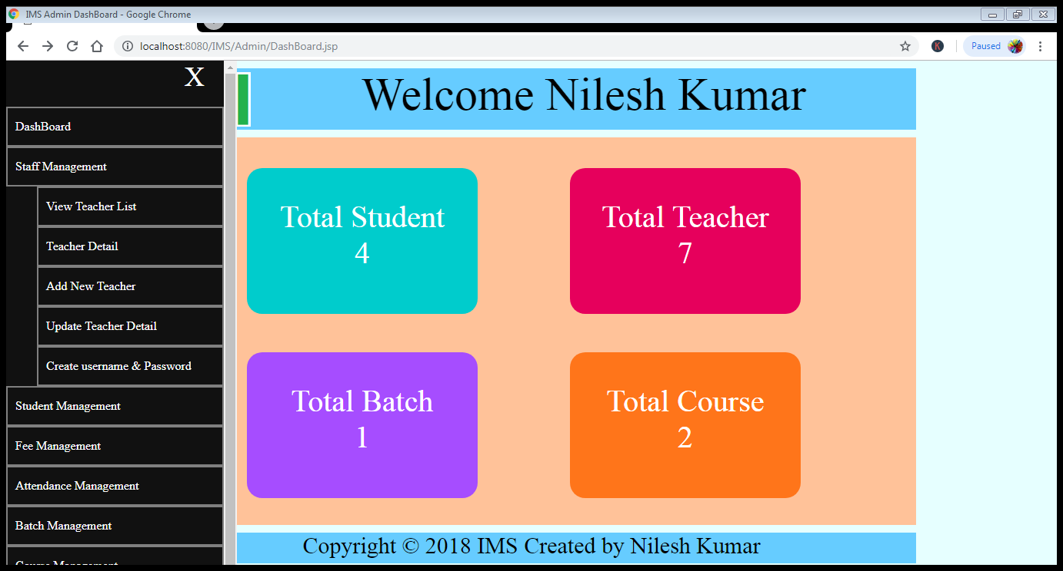

View Teacher List it will open Teacher_List.jsp page which is already mentioned above.

Teacher Detail in Staff Management it will open Teacher_Detail.jsp page

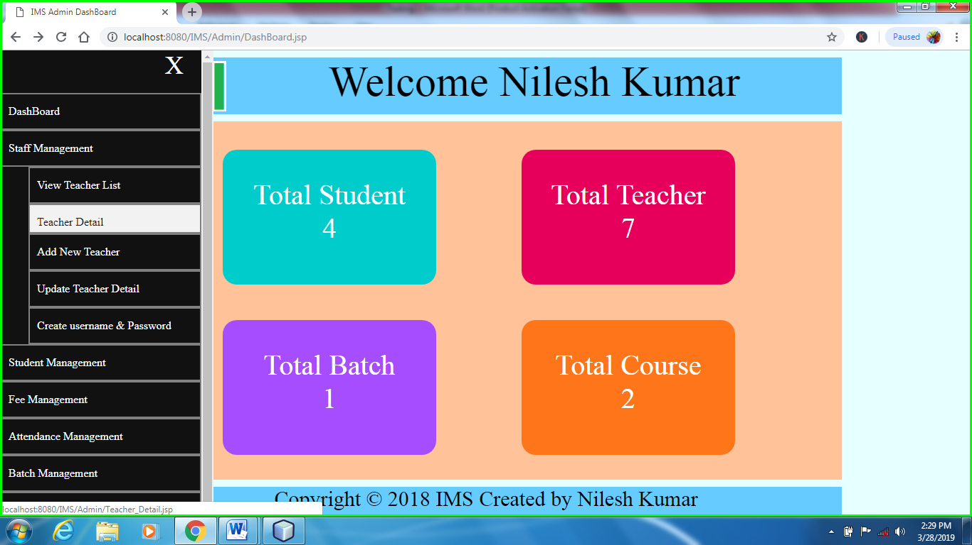

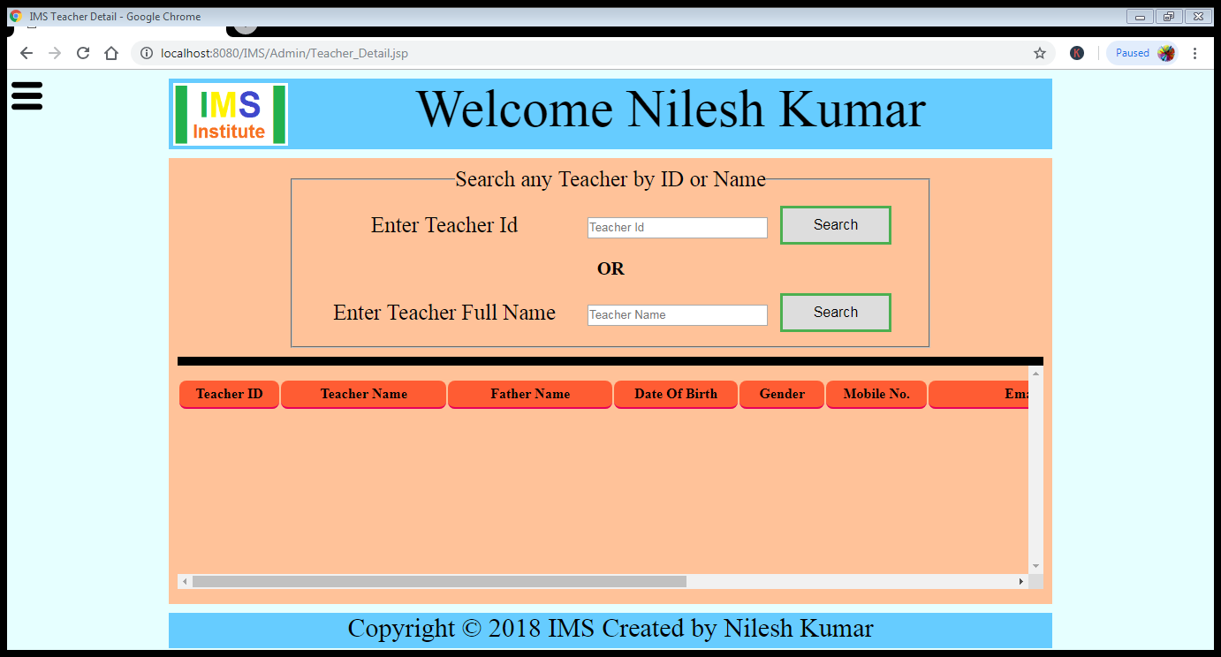

When we click on search button then it fetch the data from database and show on Teacher_Detail.jsp page

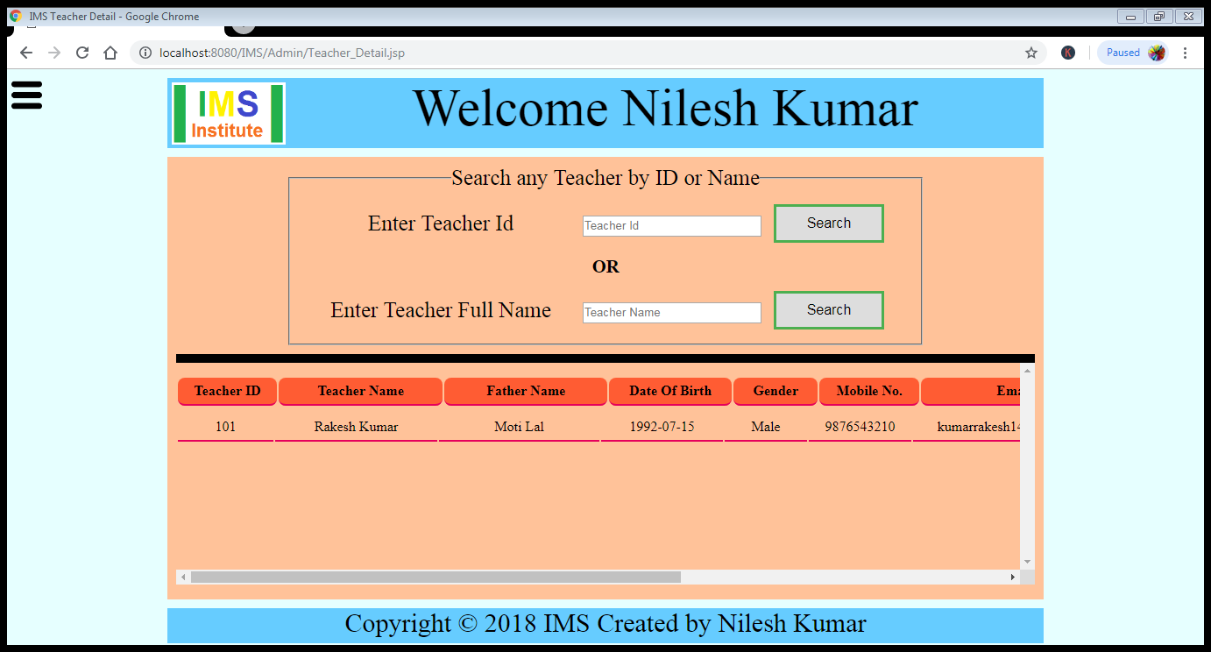

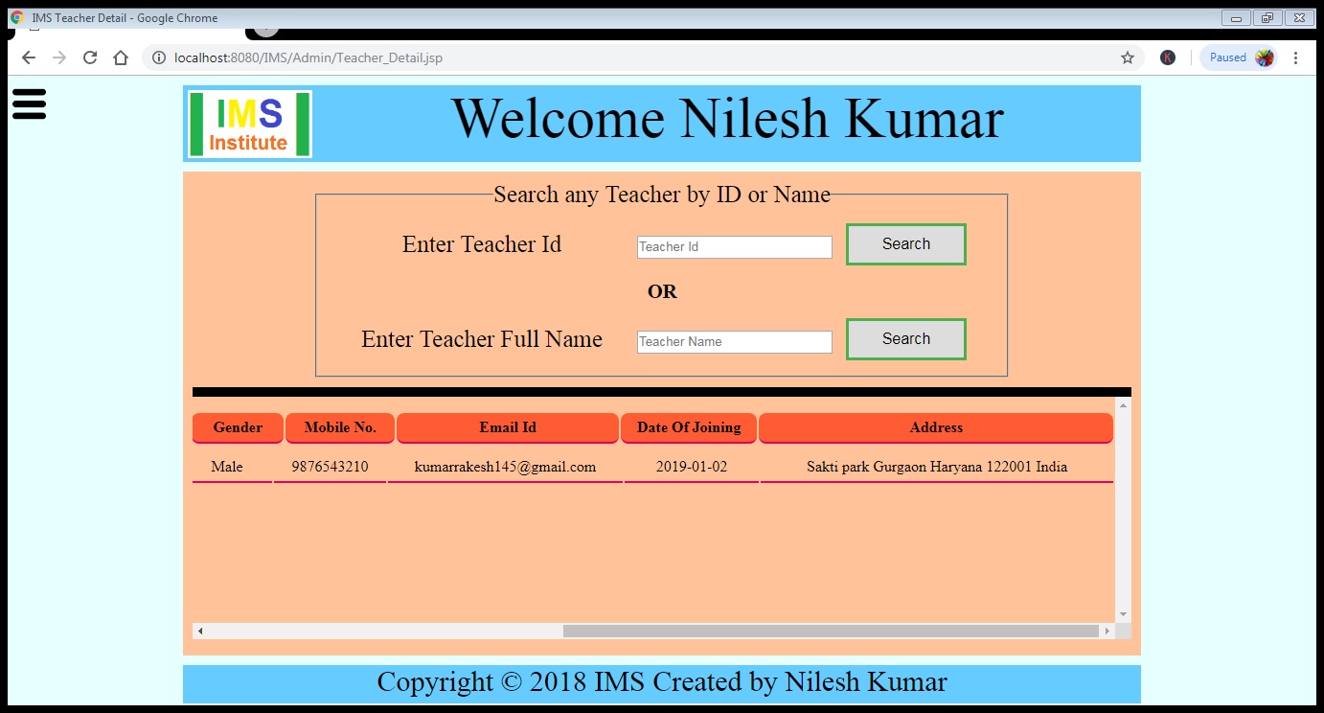

When we click on Add New Teacher button then it open Teacher_Registration.jsp page

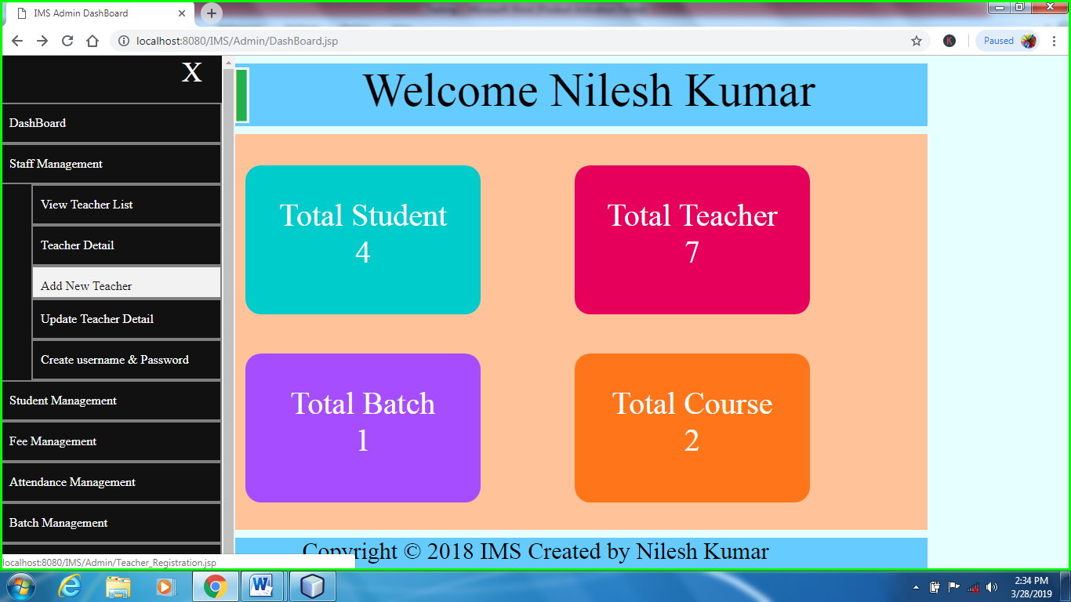

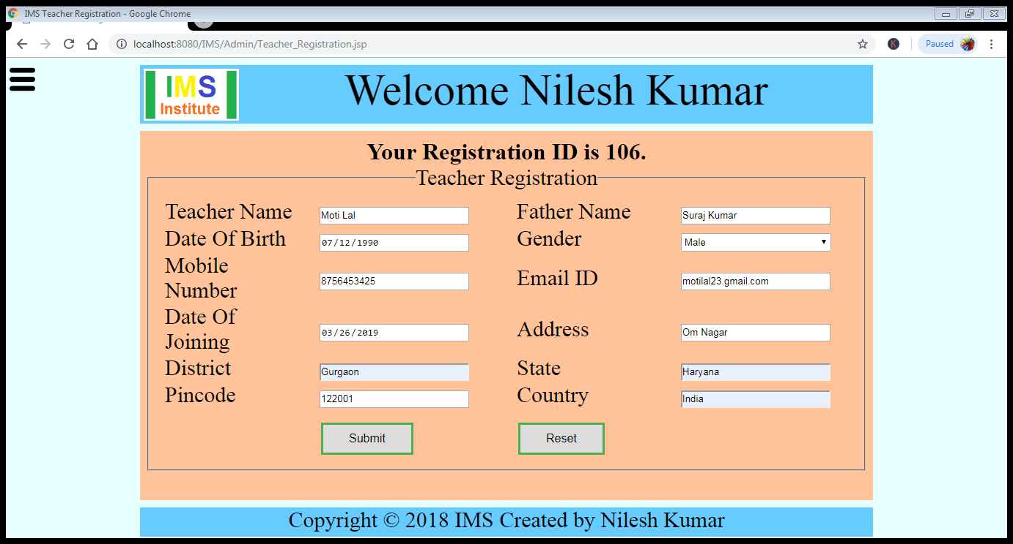

When we click on submit button it send the form data on Confirm_Teacher_Detail.jsp page

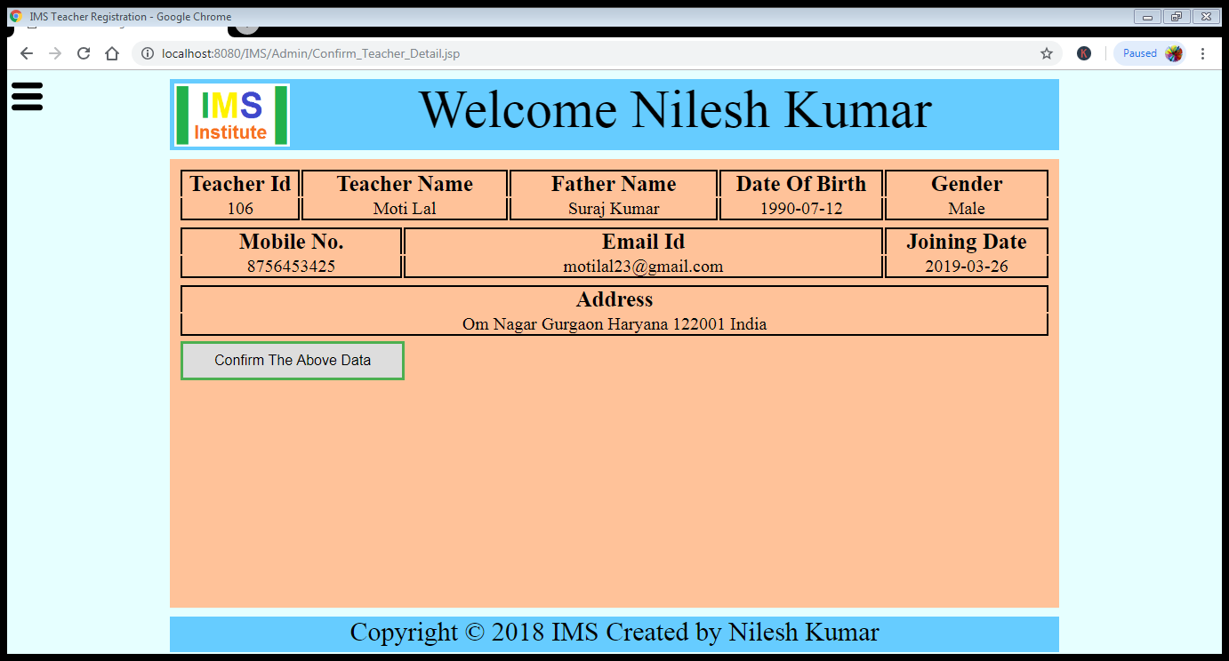

When we click on **Confirm The Above Data** it send the data on Update_Teacher.jsp and data is added in DataBase.

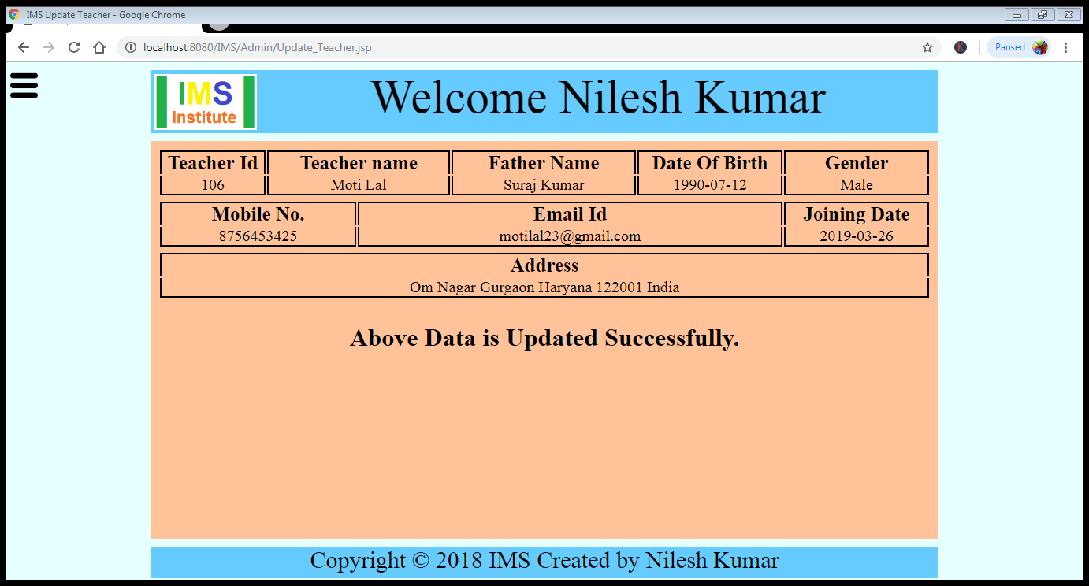

When we click on Update Teacher Detail button then it open Find_Teacher.jsp page

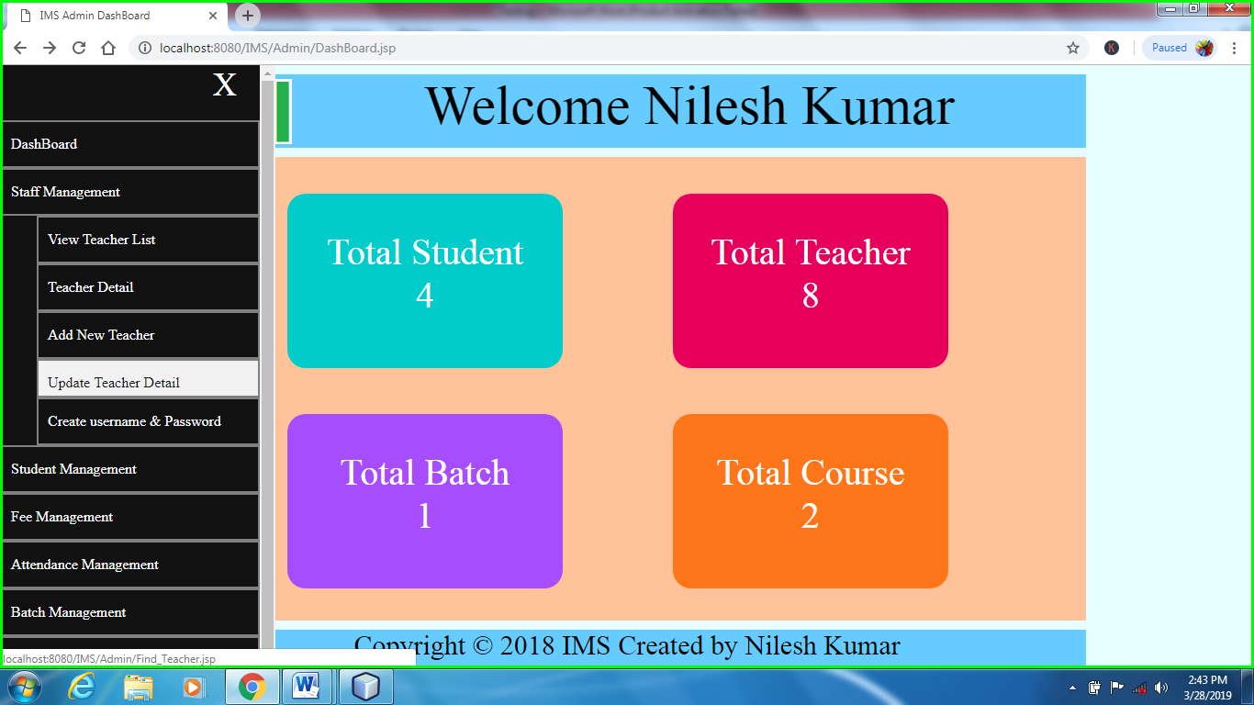

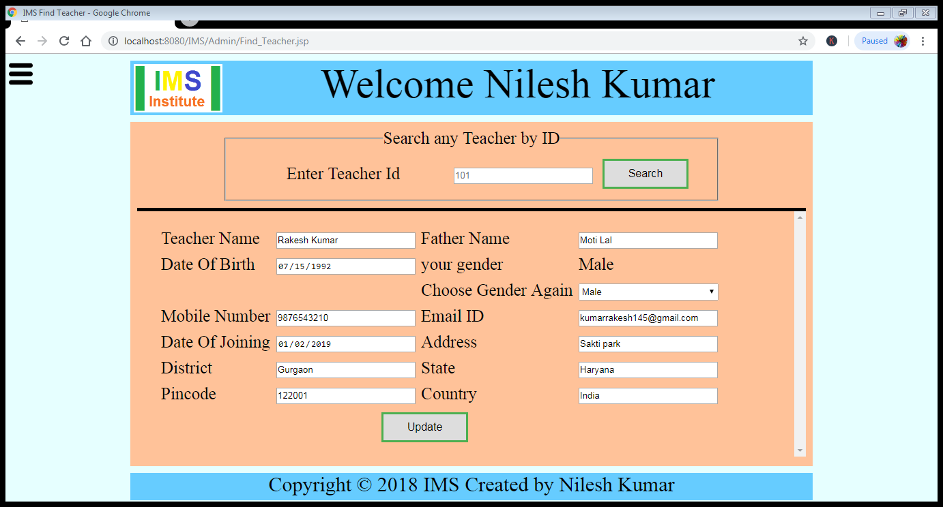

When we edit the teacher detail and click on update it will send the data on Confirm_Teacher_Detail.jsp

And when we click on confirm the above data it will send the data on Update_Teacher.jsp and data is added in DataBase as the above image

When we click on Create username & password button then it open Search_User.jsp page

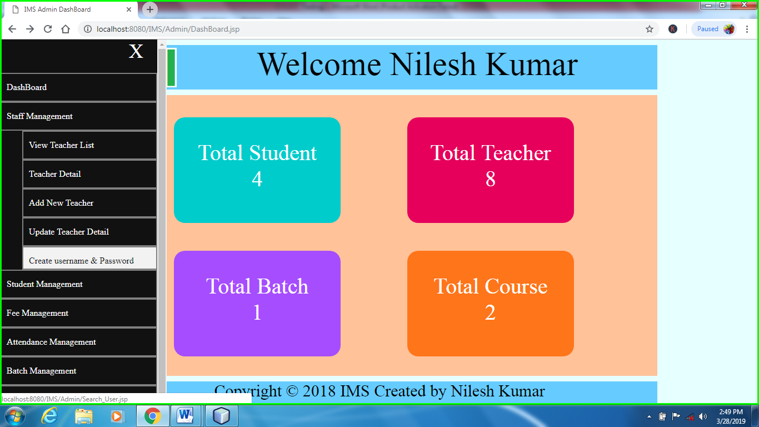

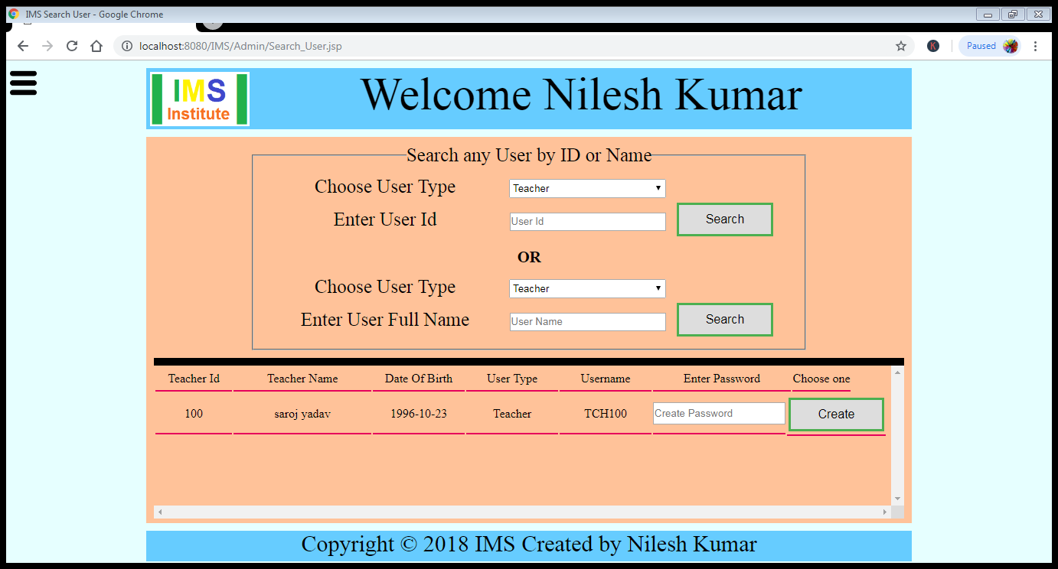

When we enter the password of the username and click on create it will send the data on Store_User.jsp page

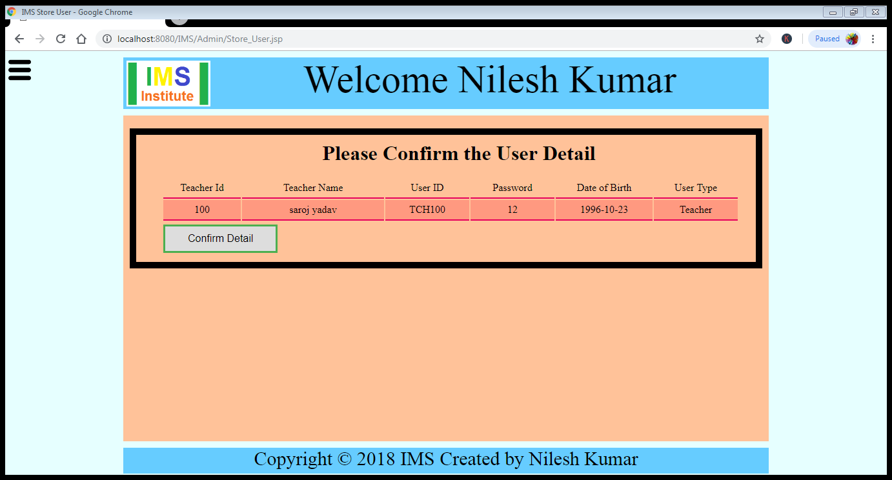

Now when we click on confirm Detail it will update the data into database

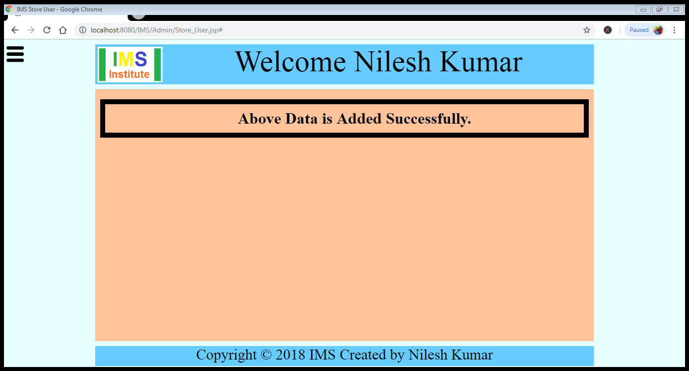

View Student List it will open Student_List.jsp page which is already mentioned above.

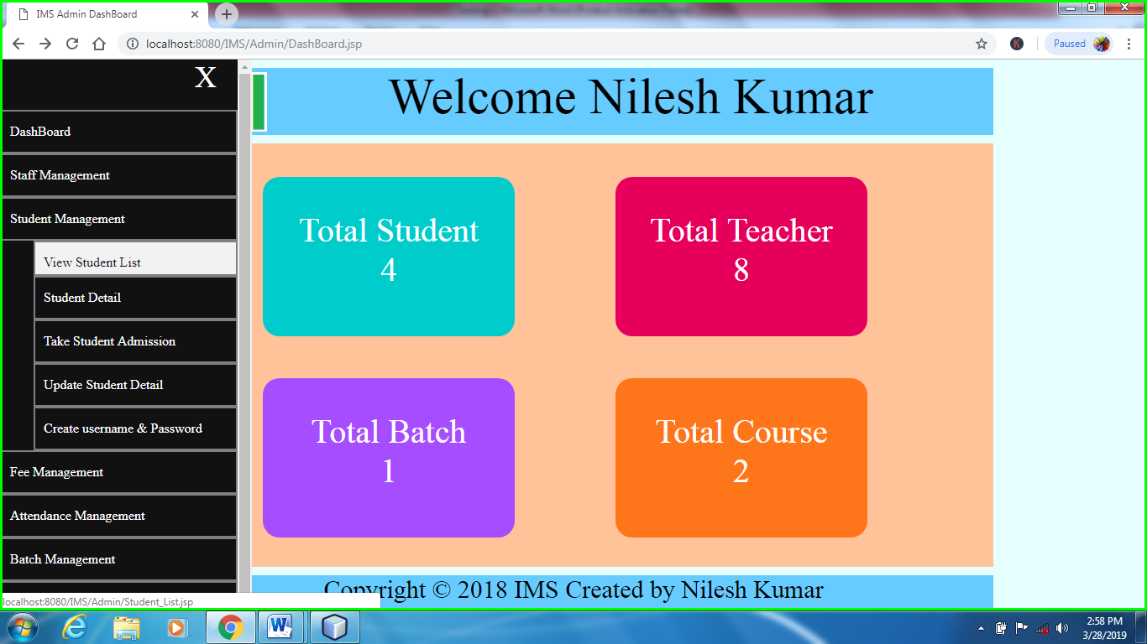

Student Detail in Student Management it will open Student_Detail.jsp page

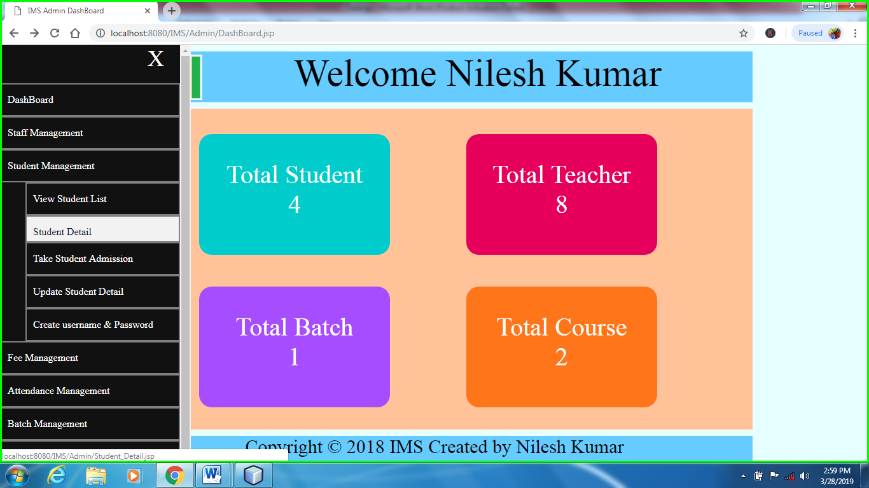

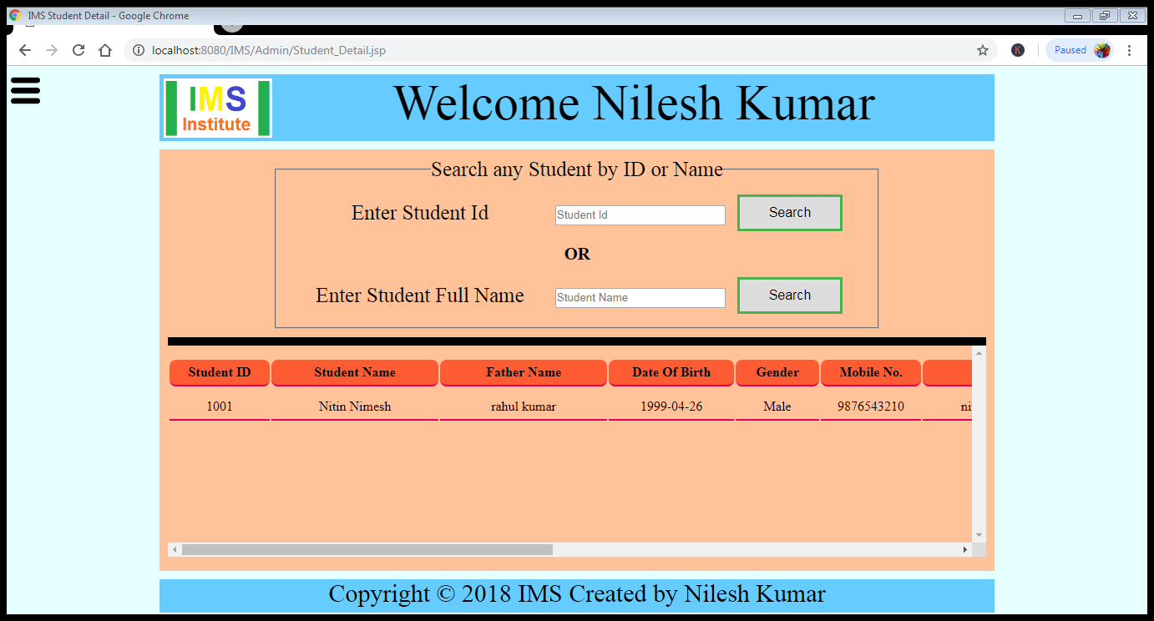

When we click on Add Student Admission button then it open Student_Registration.jsp page

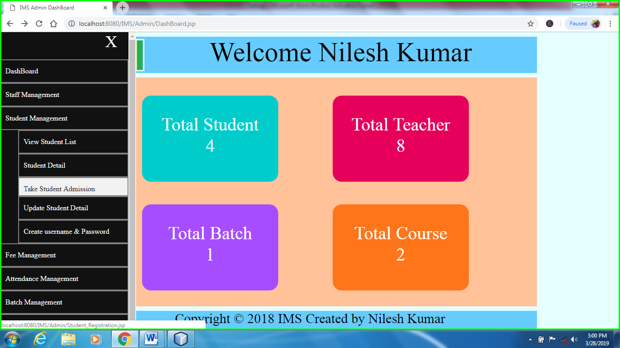

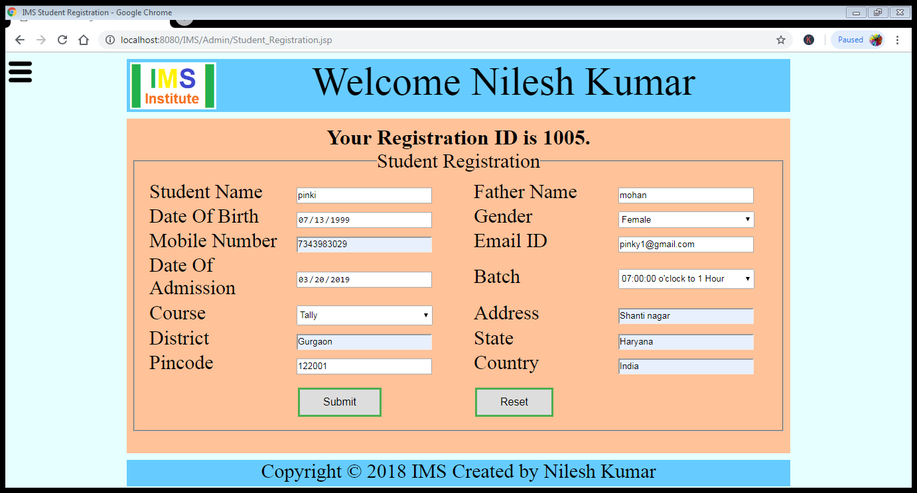

When we click on submit button it send the form data on Confirm_Student_Detail.jsp page

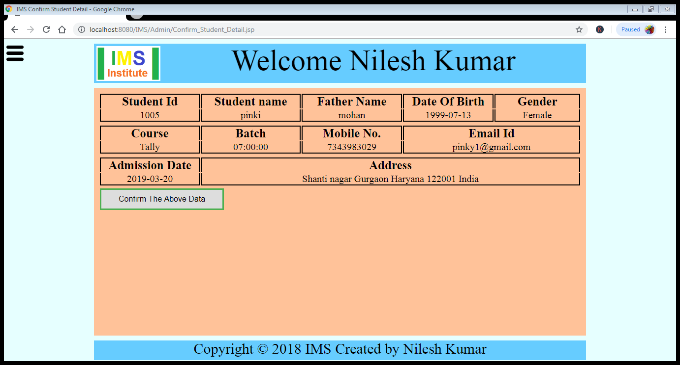

When we click on **Confirm The Above Data** it send the data on Update_Student.jsp and data is added in DataBase.

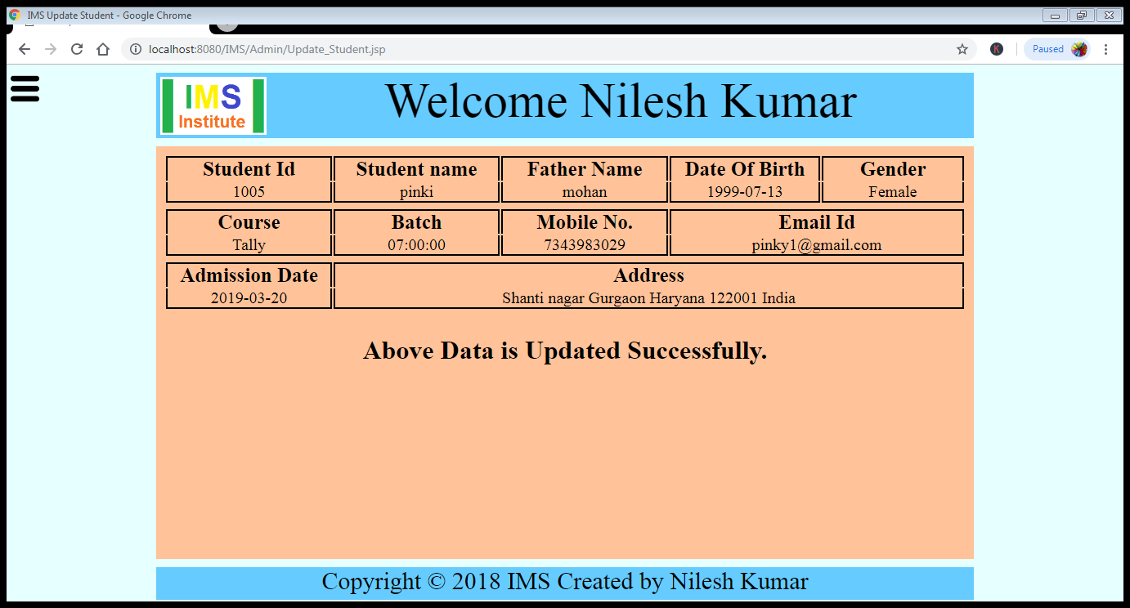

When we click on Update Student Detail button then it open Find_Student.jsp page

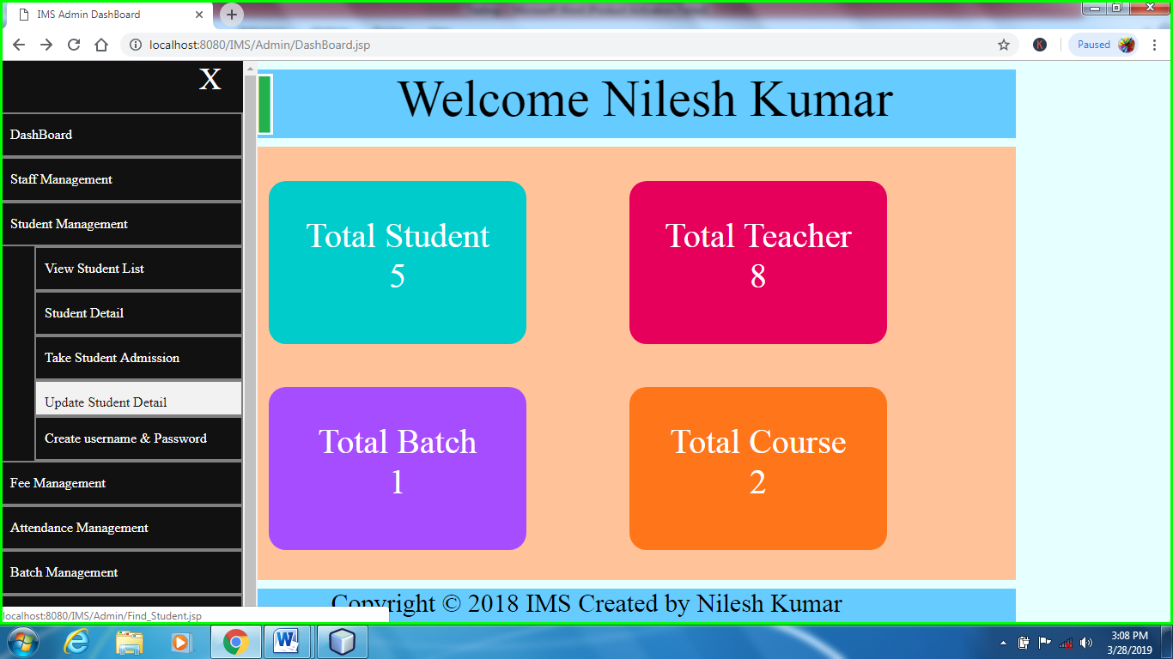

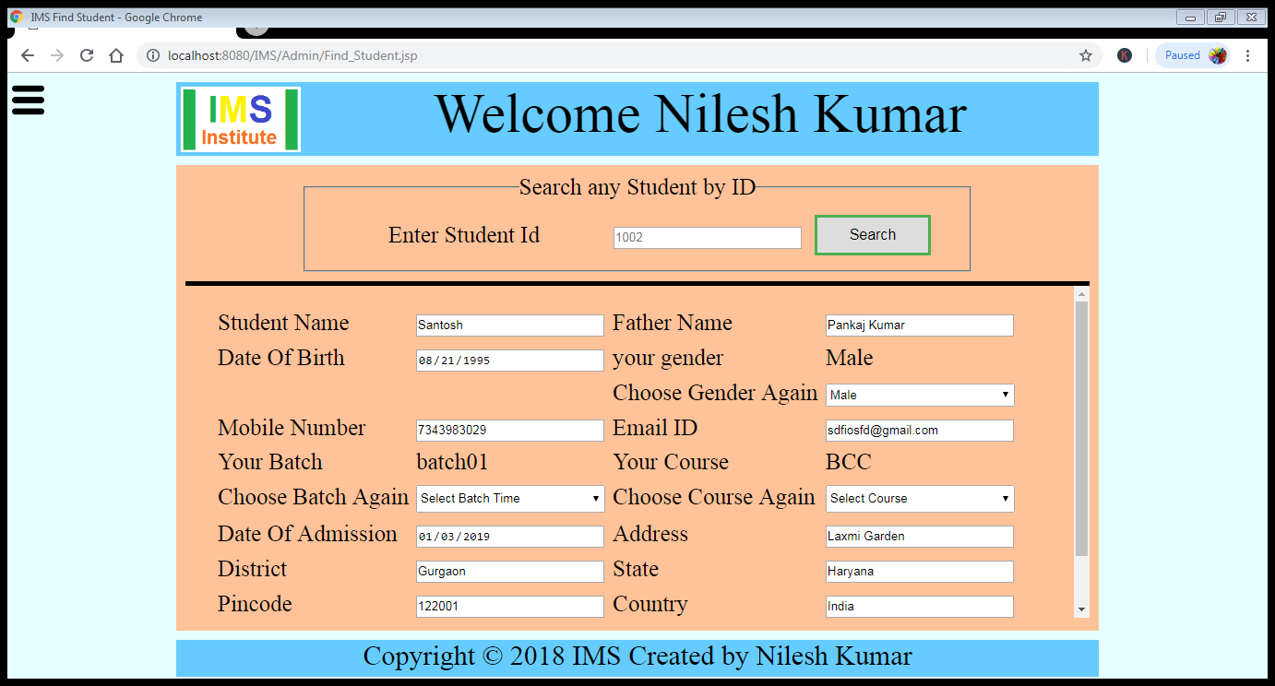

When we edit the teacher detail and click on update it will send the data on Confirm_Student_Detail.jsp

And when we click on confirm the above data it will send the data on Update_Student.jsp and data is added in DataBase as the above image.

When we click on Create Username & password button then it open Search_User.jsp page

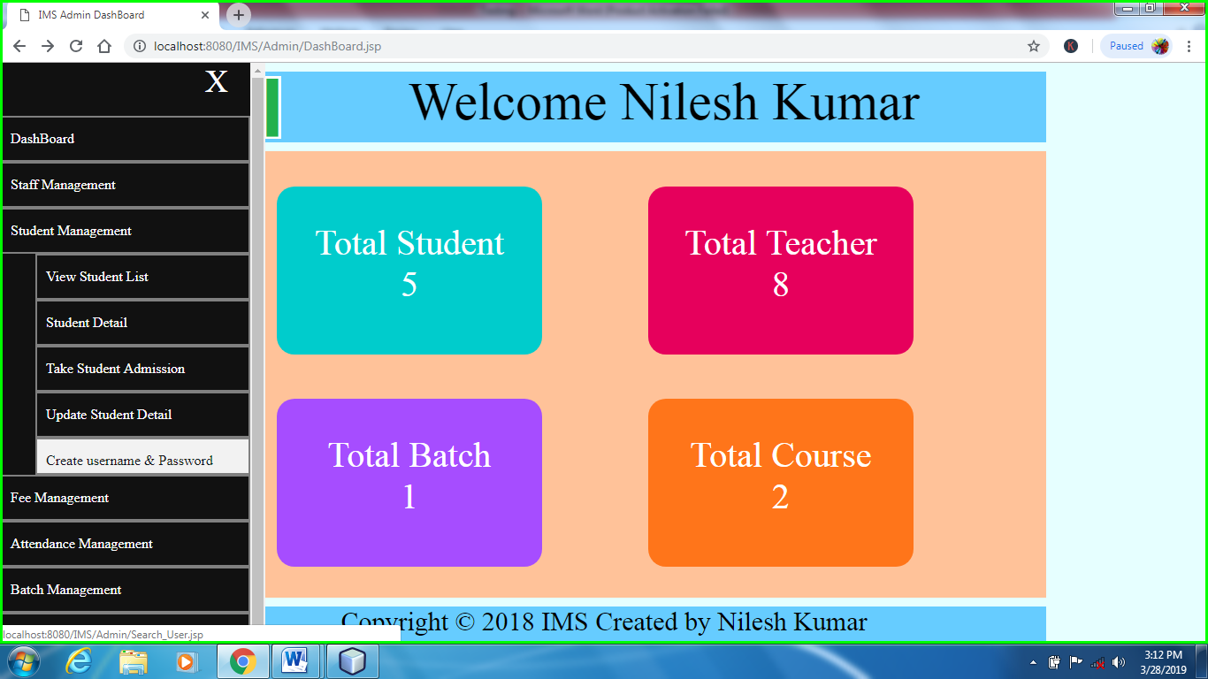

Search User of Teacher and Student are same. Just we change the user type and then it work for both according to the selection as shown in previous Images.

Change Course Fee it will open Change_Course_Fee.jsp page.

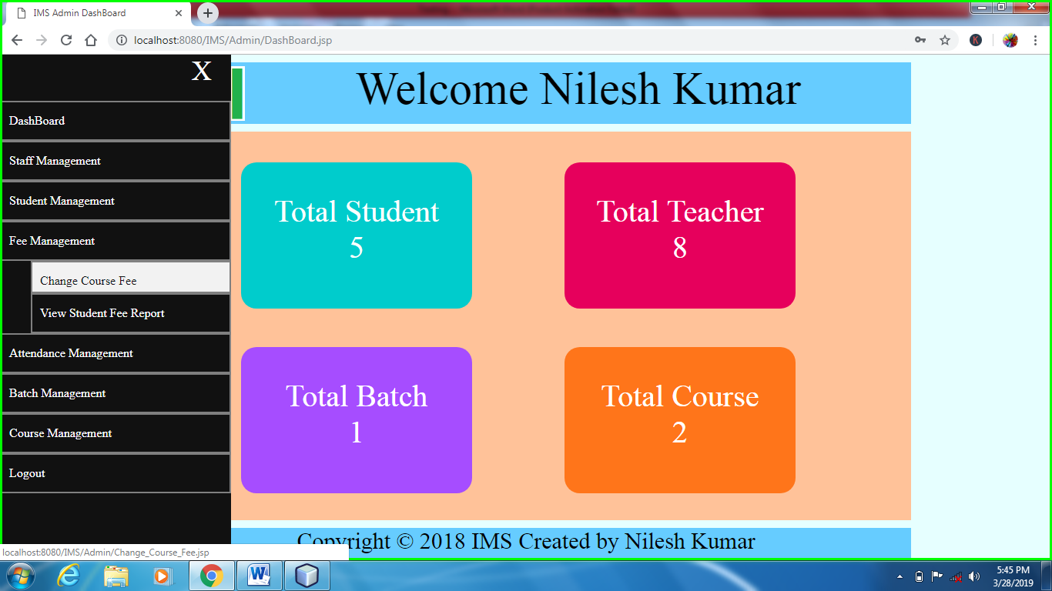

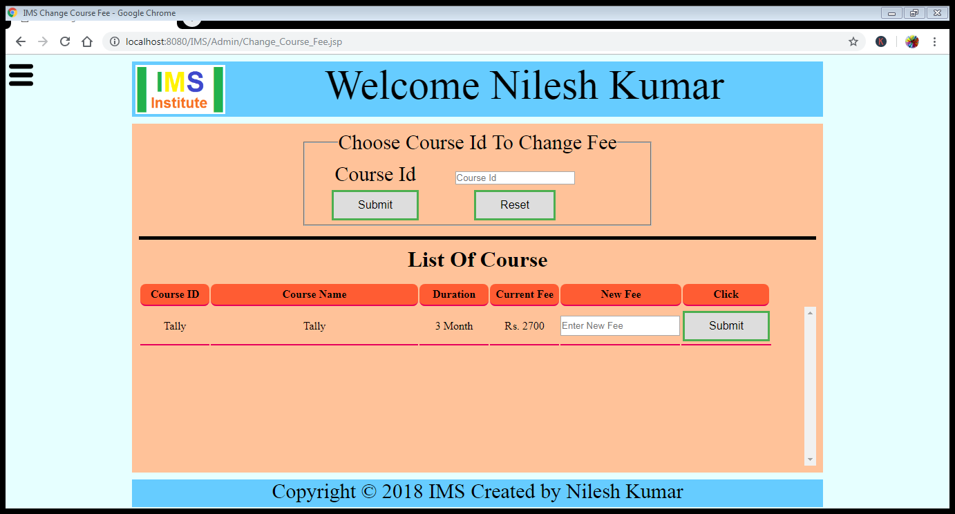

When we Enter new fee of course and click on Submit button it will send the data on Update_Course_Fee.jsp and data is updated in Database.

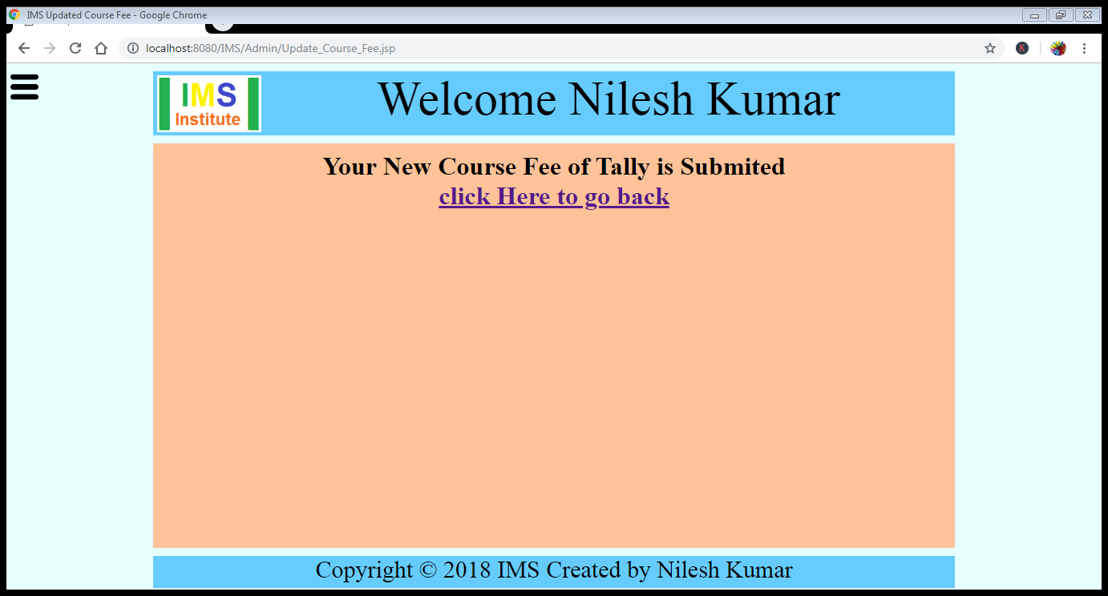

View Student Fee Report it will open Student_Fee_Report.jsp

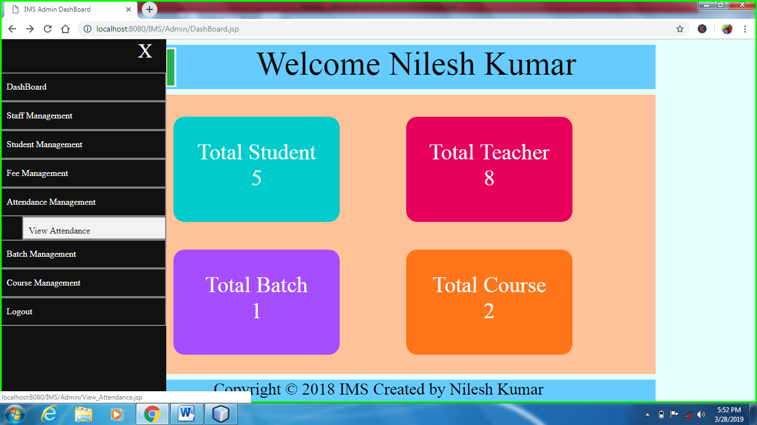

Attendance Management it will open View_Attendance.jsp

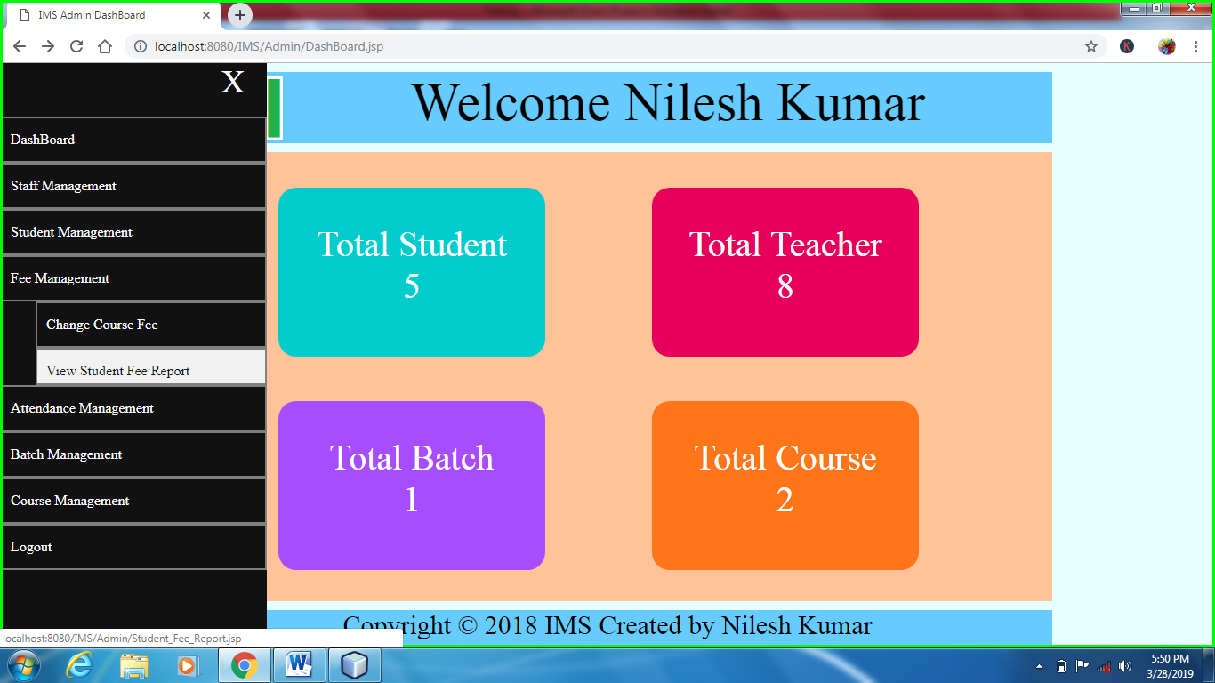

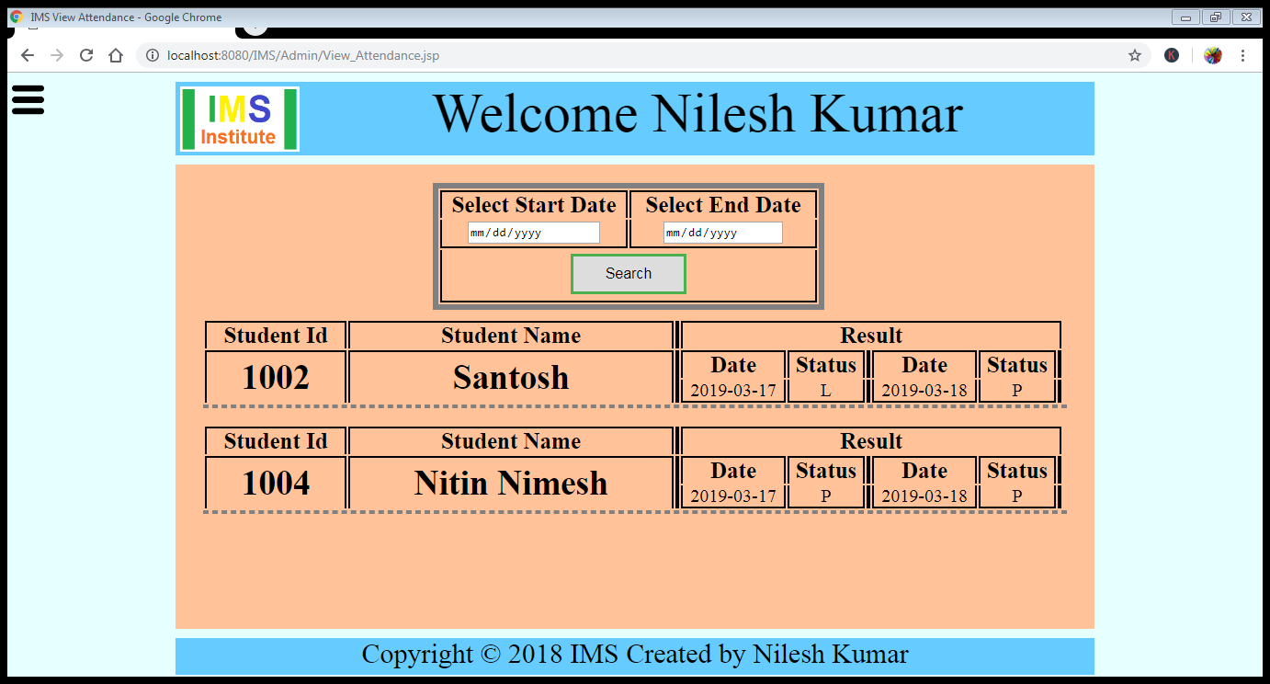

View Running Batch it will open Batch_List.jsp

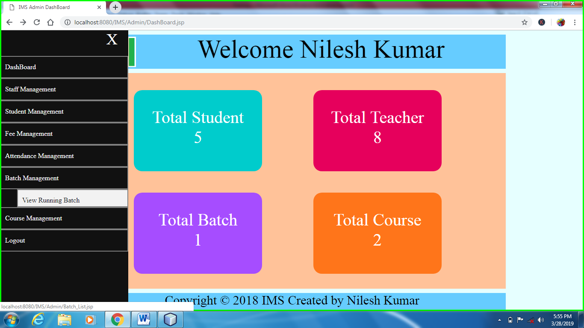

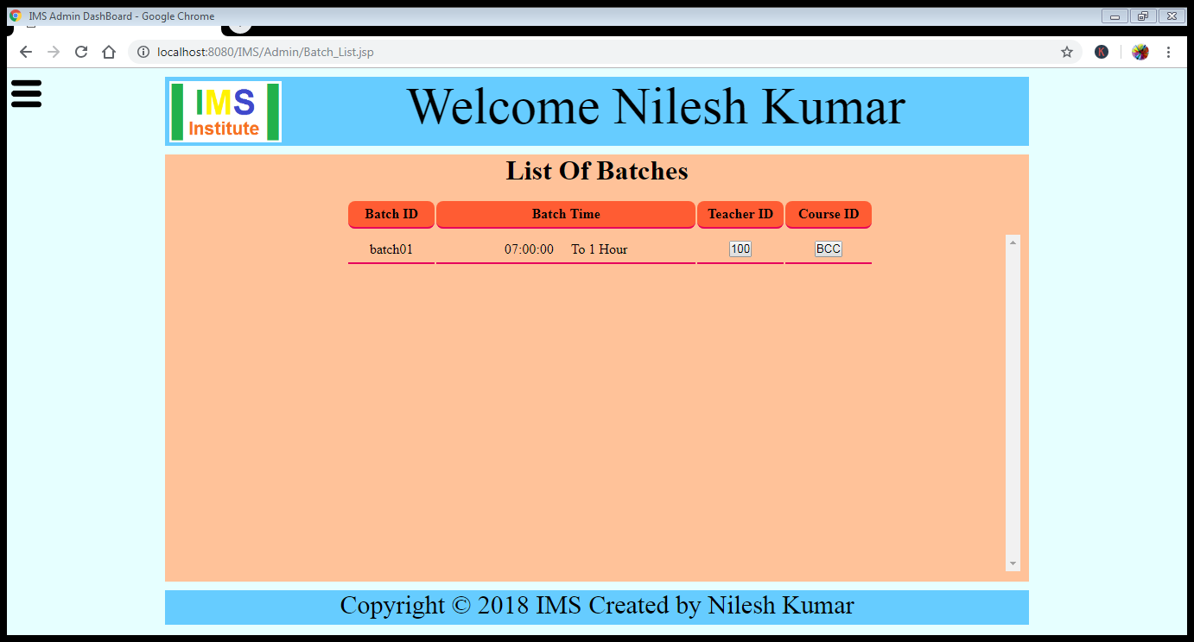

View Course Detail it will open Course_List.jsp page.

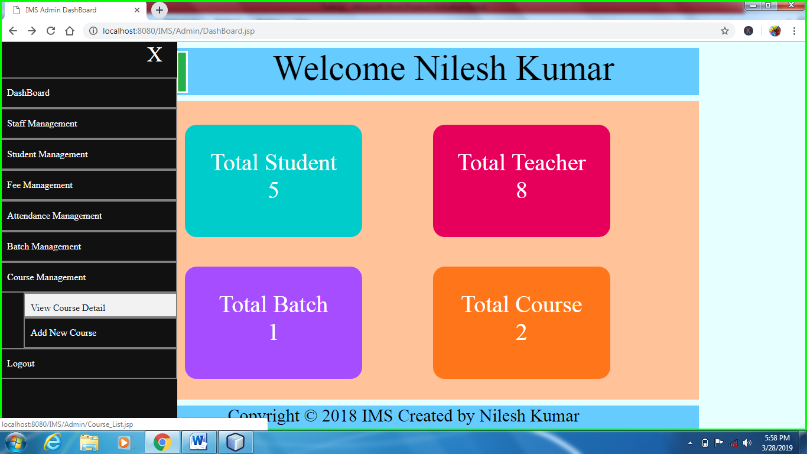

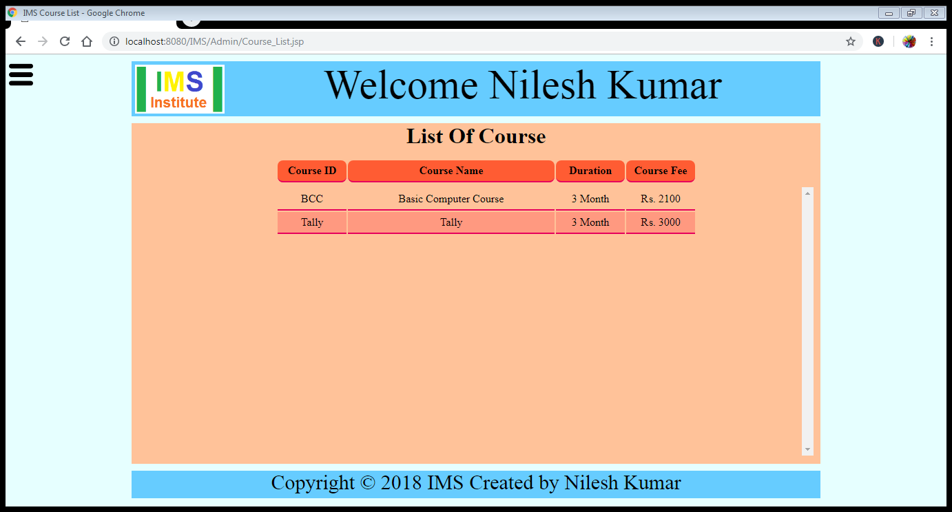

Add New Course it will open Add_New_Course.jsp page.

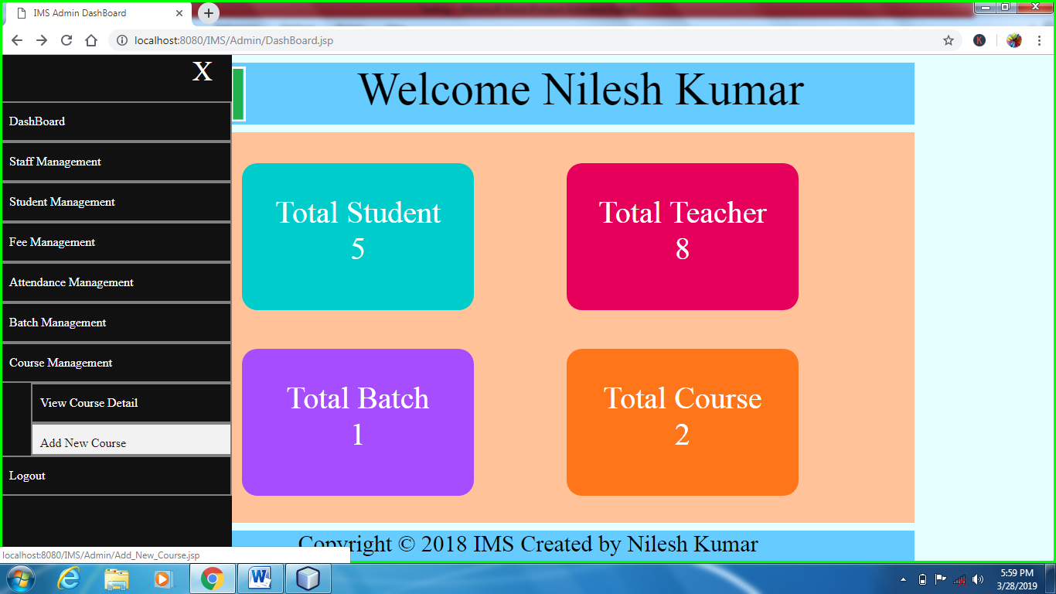

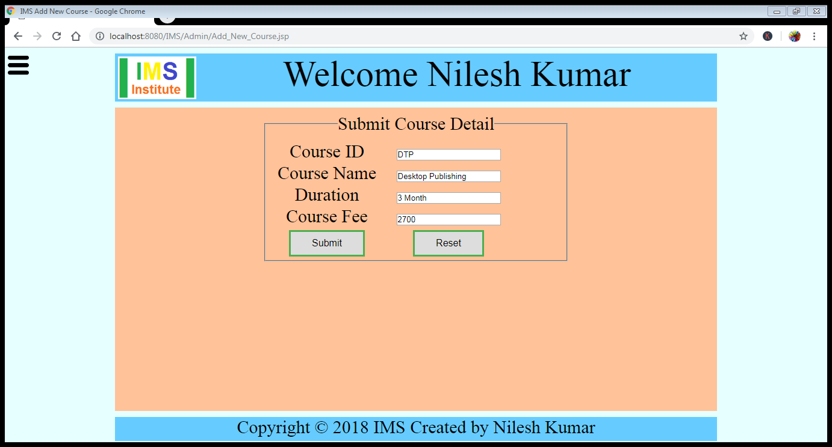

When we click submit button the data will updated in database.

